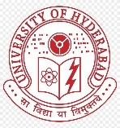 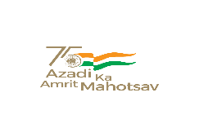 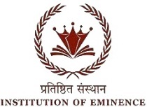

**BHARAT KA AMRIT MAHOTSAV**

UNIVERSITY OF HYDERABAD

SCHOOL OF COMPUTER AND INFORMATION SCIENCE

Collaboration with O/o Dean Student Welfare & O/o Chief Warden

Cordially invites you to Technical Sessions of Two days National Seminar on “BAM-2022“

Organized on 7th & 8th April 2022

Technical Session on “Health and lifestyle improvement through Sanatana Dharma and Artificial Intelligence”

**7th****April 4:00pm to 5:30pm** **Venue:** **New Seminar, SCIS**

|  |  |  |
| --- | --- | --- |
| **Session Chair** | Prof. Ushashree B |  |
| **Rapporteur** | Mr. Yashashvi R P |  |
| **Plenary speech by** |  | **4:00 – 4:30** |
| **Student paper presentation** | | |
| **Ms. Srijita Majumder** | Improvement of Maternal Health and mindset with the aid of AI in modern India | **4:30 – 4:45** |
| **Ms. Niharika Pennur** | Using AI and VR technologies for mental wellness using principles of Sanatana Dharma | **4:45 – 5:00** |
| **Ms. Shruti Singhania** | Studies on the intersection of Sanatana Dharma and modern day AI research | **5:00 – 5:15** |
| **Ms. Jeyapreetha M** | Using Sanatana Dharma principles to understand machine consciousness in AI | **5:15 – 5:30** |
| **Ms. Kiramaee** | A study into progress of AI research in medical domain in post-colonial India | **5:30 – 5:45** |